FORUM on BLACK MESA:
“Corporate Globalization’s Impact on Indigenous Cultural Survival”

On July 10, 2005 Black Mesa Indigenous Support initiated and loosely facilitated a public speak-out in Flagstaff, AZ, concerning the issues currently faced by the Mesa and its indigenous inhabitants. A number of people from Black Mesa made the long trip to Flagstaff to speak about the present state of the relocation process, the coal mining and the pumping of groundwater by Peabody Coal. And ultimately the struggle to maintain a traditional life on the land in the face of these. As the meeting was located at the foot of Dook’o’skliid, the San Francisco Peaks, the plan by Snowbowl ski resort to begin using Flagstaff wastewater to make snow and the Forest Service approval of that plan was also well discussed. The connection between the two issues was clarified by several Dine’ elders. Representatives from organizations working on related issues spoke as well, including the opposition to the proposed Shiprock Power Plant, the Save the Peaks Coalition, The Black Mesa Water Coalition, and the Haskell College anti-Roads campaign (Lawrence, KS). A traditional Hopi came from Hotevilla in support of the Dine’ speakers.
What you hold in your hands here is a number of selections from the speakers on that day. A full tape of the event exists and we can make copies for people who is interested. The purpose of this publication is primarily for outreach and education to those not familiar with the issues or looking for an “update”. To encourage them to support the struggle to protect the sacred mountains and the traditional way of life for the people. Then also for the people on “The Land” (Black Mesa) who did not attend the forum, to let them know what’s being said on their behalf. And finally, for the historical record, for the future generations who might wonder what was going on back then. That they might learn something from their elders and what they were struggling with way back… now.
Please read this little book carefully, and think about it seriously. A lot of work went into it. A lot of work and a lot of struggle went into every word that these survivors of the white invasion and occupation are sharing with you. As grandma Rena says, “K0hoot’4ego 1t’4 sha’1[ch7n7. T’11 hazh0’0 baa ntsidaahkees. Ts’7d1 y4igo baa 1kodanohsin. &nda k0on7 nihin11[ ch’7hoot’32 n11da’iyoo[niih ha’n7, y4igo sodadoo[zin, 7nda t’11 yeigo 1daaht’9.”
Roughly,
“This is how it is, my children.
You need to think about it very carefully.
You need to realize it fully and totally.
You need to make an offering and pray about it as hard as you can.
And then you need to do it.”

-o. johnson, a volunteer with Black Mesa Indigenous Support
8/1/05

This pamphlet was produced with the private resources and volunteer time of volunteers with Black Mesa Indigenous Support and was not funded by any grant in the name of anybody. It is not for sale and may be distributed only for free.
Translations by Sheep Dog Nation,
Transcriptions by O. Johnson.
PAULINE WHITESINGER, T1b22h1, B.F. Chishi

!ko, d77 k’ad sh7n7 hazl99d33 doo diists’a da. !din, 11d00 sh7ni hazl99. !1d00 k’ad 47 doo naagh1h1 da hazl99, k==. K== haz’33d00, D77 an7t’7’ t’47 biyi’d00 11d00 47 adishn7. An7t’i t’ahdii biyi s4d1, sh7. !1d00 ch’7deeshn4[7g77 47 doo bee sohdeesh’88[ da. H11l1 t’4iy1, doo shik’inaalnish7 da. !din. !kwe’4 t’ei bee sh22h n11h00t’iih. Dib4 47 [a t’ahdii shee h0l=, [99 d0’, b44gashii d0’. $7 doo y1daa[ti’g00 t’11 47 shik’47’go nts4skees. !1d00, sha’1[ch7n7 dan7l7inii 47 [a adahaazn1. $7 a[tso adahaazn1 77yis77 sha’1[ch7n7, t’11 sh7h7g77. $7 sh99 h1adida bighan. !1d00 doo ay0o shich’8 ndaakai da. Haash99 hoot’99hgo t’4iy1. K== bee an11h00t’i’7g77 1t’44 l1. !1d00 t’11 h0 da’ hach’8 an11hoot’i’ jileeh, l1.
!ko d77 k4yah doo baa saad h0l==d33 s1anii ay00 anoolingo ndaakai l1go baa 1koniiz99. S1anii y65 1d88h. T’11 nl47 t’11 d7zdiin d00 ashdladiin t’11 1adi d0 ]b44dahah11h din4 da 1k0daane k’ad. Sh7ni hazl99d33 s1anii doo 1d88h da yeigo n7[k’aazgo n7ch77l ndi bigodata’d00 yaago bik’7da’deesdizgo nda’ni[kaad bitsii ts’7d1 dleesh ndahalin. N1h1st’4diin daats’7 b44daahaigo 1ko bigish dah0l= yas ndeiziid, h11hg00sh99. Yas yii dadil’eezgo dib4 yich’33h ndaakai. &id33 na’neeskaadgo 1kodzaa doo k0dooniid da, azee an47[na d0 doo ha’n7i da azee baa n1’ni[go doo ha’n7i da. !ko 77d33 1[ch7n7 nish[98’go 1k0t’4ego hast07 d0’ dabitsii daalgai, 47 t’47 d0 dei7k1ah da [99 bi[ dei7ldlosh [eh. Nchx77lgo. ‘}l47 Ch’7n7l9’ hooly44d66 yish11[ nt’44 koj7go, ]l47 koj7,’ k’ad 47 Page hooly4. &id33, t’47y1 J1d7 ha’bitiin hooly44d33, ‘1adi shik’47 k44dahat’98go 1k== yish11[‘ daan7igo de7k1ah [eh. !ko ts’7d1 sh99 daats’7 ay07 1konoolningo daats’7 haz’3 [a atah honiigai ndi doo ha’n7i da. D7igi 1hoot’44d33 1ko sh7ni hazl99.

TRANSLATION
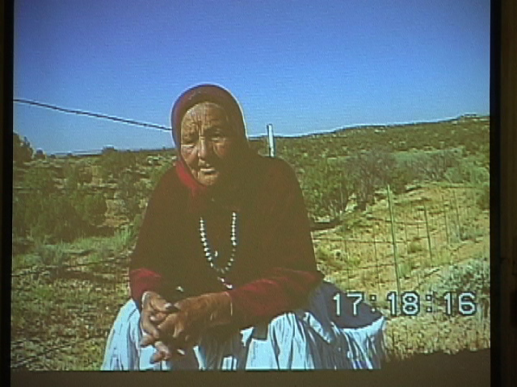
The elder here, her name’s Pauline Whitesinger. She’s one of the individuals out of about 20,000 that have been affected by the relocation policy from back in the mid-1970’s. She’s talking about how relocation has affect her people. The word relocation, as far as what she sees, what she understands, is considered the superior policy among all other policies that deal with human removal. It has really affected the life. The life before the relocation policy was way different than the life she lives today. The way she sees the environment, the way she sees her community is nothing but emptiness. That’s why she wants to say that relocation is no good. She wants such policies to be done away with. So with this emptiness she only has her sheep, some horses and some cattle. She feels like these are the only people she can talk to. Even though they don’t understand… maybe they do, but this is her family. This is how she lives out there. “However, I have children, but most of them have moved away or relocated, This is how when you are an elder, at this age, with this emptiness, this is your handicap of being abandoned. And this is how we live out here. You face obstacles every day, all kinds of hardship. And in the old days it was way different. When I was growing up I saw women, all kinds of healthy womenfolks, even women that were ninety years old with hair just like white snow or white clay. And pushing the snow around, two feet of snow around ninety years old pushing the snow around with her cane to make a trail for the sheep so they can get back into the corral. Back in those days, nobody said, “this woman fell down and hurt herself”. Women were strong.” That’s what she remembers. “You never heard about, ‘this woman’s on medication, the doctor told her to stay inside and be careful’. These were ninety year old women who’d never been to the western hospitals. Never been examined by a western doctor. They were pure, living in a pure life. This was before relocation. Life expectancy was very long. Life expectancy has been decreased. And this is what relocation has done to us.”
K’ad t’4iy1, d77 t’11 sh7 t’4iy1 din4k’eh y1shti. !1d00 sits00k4 47 doo din4 deidiits’a da. Bich’9 haasdziihgo t’00 adadik’33sgo naaz98 [eh. Nagh17g00 ata hodoolnihii hadaaghal bim1 hadaaghal, bizh4’4 d0’ hadaaghal, Shin1l7 d0’ t’11 1k0hoot’4. !ko saad45 1din. Nahg00 ha’1t’7ida bich’8 i’dool’aa[go hoghangi ndood1a[ii, 1k1 adoolwo[ii
$7 daats’7 0oly4, t’00 ho[ hodiilk-.
1din. K0t’44 g0ne de7n7ik11h, d77 s1anii doo da’7ilta’1 47 t’11 nih7 t’4iy1. 1k0t’4ego nihi[ dahw4elzh77sh. !1d00 d77 k4yah baa saad h0l0n7g77, doo baa saad h0l==g00 doo bee nih4’4ts’ihg00 k’ad nin11hoot’4 kwe’4 k0n11hoot’4 doo nihidi’n7ig00, t’11 1ko sh99 s1anii koniidl== nt’44 din4 da sh99 honii… hadaastih7g77 h0l=- doo ]t’44. !kw7inisin 47 n1t’32jigo nts7n1skees. Kod00 n11n1 n1asjigo t’4iy1, nihits00k4 47 h1adish99 [a da’ts7st[‘11y1ago 7nda hadoodzih. “Shich0 h0l== nt’44, nihicheii d0’ t’11 hwii[ts3” didoonii[. “!1d00 shin1l7 da h0l== nt’44” didoonii[, haa sh99 yit’44sh99 k0didoonii[, doo sh99 47 t’11 1t’4 da. $7, 47 t’1adoo shi[ hojoolne da. T’1adoo shi[ ch7hozhn7’32 da”, didoonii[. !adi 47 nihik’7hodidoot’aa[. A[k’id33 s3 danihiigh32go 47 nihik’ih1t’1ago !k0t’4ego sh7 baa nts4skees. !adi nt’44 b7dei7k1ah da hadadoodzih, 1adi ts7st[‘ahazkaigo 7nda. !ko 7nda n1t’32jigoin4e haash99 n7zaadi bints4kees da nik7dadoolwo[. !1d00 d77 k4yah, d77 bik4yah 47 ah1din.
She said living under the policies of relocation makes you think about a lot of things, not only what’s happening to you. Part of the stress is that you think about the old days a lot. “As I have mentioned about the strong womenfolks, there were also strong men, beautiful men, back in those days that had white hair. They rode horses all the time, they traveled distances using horses. I think about how strong those people were. I’ve seen many travelers come through our area of the land and stop in and people would be kind to them, make dinner for these strangers that came through. Men would say, ‘I’m on my way to Antelope Pass (near Page)’ or, ‘I’m on my way from Chinle. I have relatives way out there and I’m gonna go visit them for a while’.
“I feel like I’m the only one that can speak the dine language. Our grandchildren and great grandchildren cannot give us answers when we talk to them. You ask them something and they just shrug their shoulders”. Like they’re doing Yoga or something. That’s the only answer they give you. So that’s the way she lives and its hard to be the only one speaking Dine because you can’t instruct them to say, “take the sheep out at this time”, or give instructions about the chores around the land. So its hard to maintain the lifestyle out there because our language is being lost. She says, “So I guess that’s what they mean when they say in the old days that you’ve been defeated, you’ve been conquered, your whole world has been leveled. That’s kind of the way I feel in my life right now. Our lives have been leveled. This is the way that we live and this is the way that our journeys are under these policies today. If there were no relocation…,” she thinks, or just her hopes for the future, “someday we will start to have strong people again, strong womenfolks.” This is what she would hope for. And even old people would be strong again instead of being sent of to nursing homes, and we would have all the old folks with us, even the very old ones. She also says that some day the young people are going to say, “I had grandparents, A long time ago I had a grandfather. I had nalis and soon.” These grandkids are gonna start saying these things. Maybe not a lot but some of them. “And they are gonna blame us,” she says, “even though we’ve been gone a long time. My grandchildren are gonna blame me. They’re gonna say, ‘well, she never taught anything, she never left anything.” So this is how she feels today. And this is gonna happen. There is no way that it cannot happen. Some day they’re gonna face some hardship and they’re gonna be looking backwards. So I’m kind of looking at what the future has to bring.
D77 sh7 t’47y1, baa nts4skeesgo d77 bee nihaa saad h0l=n7g77, k4yah ha’n7n7g77, ts’7d1 y47go 1[ch7n7 nil7n7g77 t’11 y47go da’77[ta’7g77 t’11 daats’7 ts’77d doo deey1h7g77 47 d0’nih22h daj0b4. W0n11sd00 47 at’44k4, h1adish99 47 t’1adoo yishch98 da 1adi shich’33h naaldzilgo sh7 47 kodi s4d1a doo jin7 nahalingo k== da’ahijig3 ha’n7igo 1k== ahik11h. Da’ahijig1 ha’n7n7g77 bi[ ah7iltsood. K4yah baa saad h0l= nih7 kodi d0’ 1k0nihidil’9. K’ad65ni t’00 silao bi[ danihi’diiyeeh. Kodi y65ni a[tso h1adish99 adanihizy=- daats’7 t’11 sh== doo daa t’11 1j7t’4h4g00 daats’7 an1hizhdookah. K== da’ baa nts1h1kees. Ts’7d1 y47go nts1h1kees doo 44hozin da. T’11 1jiiy32go, t’11 ajiiy3 t’11 1dazh’dit’ahj8 hach’9 nahwii[n1. !ko d77 nl47 t0 w0naan7di din4 an11n11sd88d ha’n7…
This is, I think it’s a good thing to try and understand what its like in the mind of someone who is facing this relocation policy all the time, 24/7. That’s how a lot of these traditional people are. The way that they see the world from within their own communities and looking at outside. She continues to say, “Under the relocation policy has also broken up the family structures. It doesn’t provide a setting where we can give traditional teachings to our grandchildren. That connection has been severed through these relocation policies. One example is that our children have been taken away. ‘They are going to be educated and they are going to be used for our own purposes,’ is what we are told. This was made to be the law. Then they say, ‘I can use your daughter. I can make her into a soldier to go fight this war in Iraq.’ This war is attatched to the relocation. They are very similar. We face an army of soldiers if we try to do anything, And before long we may well face an army of soldiers for doing nothing, that will start enforcing the relocation law. ” This is how she feels like there’s no peace where she lives. The relocation policy has done this. She also wonders if those who have been taken will someday be free, someday free to return to your homeland. She said, “This is what you think about even down to the very minute of the day. Even as you are trying to enjoy a peaceful meal. When you’re ready to take that bite of food, this is on your mind.” So it’s not a pleasant thing when you’re under this policy and you want to forget it and just think about the good things but it’s very very hard.
She wanted also to say something about an issue that is happing here, that is happening near this community…
T’11 nl47 nihe’ezis biyi’ g0ne’4 nda’ach’id, k’ad. !adi, nl47di nihit1d7d77n si[tsoozgo 47 nda’ni[tso’go h11dadi[tsoos. D77 nl11hg00 ahidoolg33[. D77 t’1adoo nl9n7 dago daats’7 1t’4. T’00 1k0t’1o 47 baa nts4skees t’ah nt’44 n1ahosid4ts’33. Asdz1n7 nil98go haadz77. ‘Nl47, Naak’o’os[77d 47 ]didoogo[“. !ko ]t’44, haash99 yit’4ego baa ntsid4k44z, 1adi hadzood77 ha’n0. Hapitcho 47 yii[ts3, naaltsoos aseez7n7 bik1a’ii. T’00 baa iihgo nih1 hadzoodz77. Ch’00shd33d33 nihe’ezis bii’n7zhd7lnih. K’ad nt’44 4iy1 nihichaan7g77 baa saad hodzis[99. $7 biyaa dah deeshnih doo. Nihichaan7g77 kwe’4 choidoo’88[, Naak’o’os[77d b22hgi nihijin7. Hait 1osh 47 asdz1n7 jil98go, 47 1k0t’10 nihiji’1a’ doo? S1anii sh99 jil98go dine doo abijin7i da. Nisin. !ko Nd7shch77 binant’a’7 jil9, ha’n7. Nd7shch77 woly4eiid00 hazl99 shi[ b44hozin sin hazl99 ndi shi[ b44hozin, Doo din4 1yiilaa da, 47. Doo b7la’ashdla’ii binaashnish da, 47. K0t’4ego t’4iy1, nihim1s1n7, nihicheii da t’11 yaa ch’7dahwiiz’3. Ha’at’4ego0sh binant’a’7 jil9? Baa n11’iiniih65 naat’1anii yee 1daat’4. Doo sh99 t’11 adzaag00 baa y1dji[ti da. Biniinaago 47 1k== k’ad nihich’8 nin1hodiilt[i’. !ko d77 k’ad 47 t’11 aan77g00 t’11 1k0t’4ego t’11 hazh0’0 doodah1 g0ne nihid7n0olka[go 1t’4. Hataa[ii 47 doo bi’77sts’32 da!
She is saying that the way she sees this issue with the desecration of the mountain and she feels it, even though she is isolated and doesn’t get much of the information, is she feels that the government is digging in her medicine bundle. They’re feeling around in there and they’re pulling out certain things, they’re pulling out the corn pollen, the most sacred offering thing that we have, and throwing it away, saying, “That is useless anymore, in this century. You guys don’t need it, there’s a better belief for you”. This is how we’re being treated. According to the people who are making these proposals and these policies to expand operation on the mountain, to use wastewater to make snow, that has no worth, the corn pollen. She hears that there are women involved in this decision and planning to carve up the sacred mountain and then they are saying to take human feces, and use it up on the mountain. She says that this is very embarrassing to her as a woman. She is ashamed that a woman would make such a decision to harm the mountain. To harm life. It is disrespectful to hear that a woman is making this decision. And the Forest Service. They call themselves administrators of the forest. They do not know nothing about the forest. “What I have learned as an indigenous person is that we Indian people know about the forest. The ponderosa tree is very sacred to us. We know the stories about them. We have knowledge like this that has been given to us by our ancestors. The real administration of the forest is located in a prayer. It is in the practice of offering corn pollen for the use of even the tiniest piece of a ponderosa for a ceremony.
And in the sacred stones that we offer, this is what is called “administration of the forest”. If there are human beings who are gonna make policies about these forests, and if we dispute and fight over it and one wants to exploit it, then the forest will administer itself. This is already underway. The flames are working their way towards us and the smoke is in the air.” So this is what we live under as traditional people. Even if it’s happening out here, it is affecting her. It is felt through her medicine bundle. I think this is a concept that is really difficult to understand. For this last part she is gonna talk about the coal mining up there.
!ko 47 b22h na’ageed doo b7k1 hasti da. $7 sh99 biniinaa nihilid’ w0shd66 nihidi’n7. Nisin [eh. Dzi[ &jiin asdz33 bizid b22h nda’digeed, bij47 b22h nda’digeed bits’33d00 b7k1 1deezt’i. Nihits’33 da’dziisx98’go, T’00 nihi[ hadoo[das nahalin. Bij47 hadadzis’3, hazh0’0go. Hazh0’0 bits33 dahoj77y32. $7 sh99 t’4iy1 naaly4h4 sh99 1t’4ego, 47 n7[ch’i halne’4 biyi’j8 t’00 diists’a. Nih7, h1’7da’haye’nil. Joe Shirley jooly4h7g77 n7[ch’ihalne’4 biyi’j8 shin11[ hadzoodz77: ‘hada’ag4d7g77 hada’ohg44d d77niid’ jin7. Doo 1k0t’4e da. Doo 47 biniiy4 h11’7da’iye’nil da. Nihich’ij7go dziz98 doo biniiy4’ !k0t’4ego haa nts4skees nt’44. Dzi[ &jiin, asdz33, da’dziisx98’go, doo y1’1t 4eh da. T0 t’11 1din. D77 sh7 s4d1h7gi t0 t’11 nl47 w0yah hadaazl99 [eh nt’44 nl47 T0naneesd7z7 bich’9 t0 1k== danil98 [eh nt’44 bikooh g0yaa. K’ad 47 t0 1din. Ahb7n7go t00gi n1shd11h. T’00 naazk3. !k0t’4 1ko ‘t0 47 h0l=’ dajin7. Doo 47 h0l=- da. T’11 a[tsog00 t0 1din t0 hadaazl7n7 t’11 shiid32’dii t0 hadaach’i’go doo a]daad88h65g00 1daadin t’00 dahazgan. $7 l1 y47go sh7 diish‘1. {eejin hada’ag4d7g77 ni’1lyaa’go. Naanish sh99 dah0l=. T’11 h11g00dash99 naanish dah0l=. T’11sh 47 t’47y1 naanish? Nahg00 sh99 naanish dah0l=. Doo 47y1 nahasdz11n biyi’j8 yigo[ da. Doo bee nih1 haz’32 da. Nl47 din4 nihi’di’n7n7g77. !1d00 Bilag1anaa7g77 47 t’11 7iyis77 b7h0ln77h 47 han1dzihgo b7h0ln77h ah44’iikaah doon7[7g77 doo y1’1t’4eh da. J0 1kon: ts7st[‘adanihizh’eezh. ![ch7n7 da’77[ta’32 t’00 h1adi sh99 t’00 1d88[, ha’n7, 1ko. T’11 h0 aj7t’9.
She’s talking about the Black Mesa coal mining by Peabody Western Coal Company. She lives about 15 miles south of there as the crow flies. It’s very noticeable because every time they blast you see the clouds of dust annd smoke coming up on the horizon. In the morning you have the petrol exhaust and the dust from the blast settling down in the canyon, Blue Canyon, in that area where she lives. So she says that the land that she is living on is also affected by the coal mining. To her people there the land is called Dzi[ Ijiin Asdz33, the dark mountain woman. This is how they know this land, the Black Mesa area. She is a great spirit, this is what she was told. Today she is also being disrespected with the coal mining operations up on top. Again they are taking a precious thing from her body, a sacred thing. It is a similar thing to the forest service saying that we want to use your urine up on top of the mountain. The coal mine is carving out this Great Spirit, that is a physical being, that is alive; that breathes, that thinks. Our very mother is being carved up there. They have dug into her body and extracted chunks of her liver and they are carrying them off. Maybe bits of her lungs as well, taking that all out. We know that once her internal organs have been extracted that humanity is gonna start experiencing all kind of diseases from this. From this thing that they did, from butchering the mother alive. If the mine is further permitted or expanded, the coal company will eventually kill her. Once she dies, there will be nothing left inside of her and her body will collapse. We will go with this collapse and we will be buried within all this rubble at the bottom of this sunken collapsed area. This is what can be expected if we allow the mining to continue. Eventually they will pull her heart out and that will of course kill her.
T’11 nl47 nihe’ezis biyi’ g0ne’4 nda’ach’id, k’ad. !adi, nl47di nihit1d7d77n si[tsoozgo 47 nda’ni[tso’go h11dadi[tsoos. ‘D77 nl11hg00 ahidoolg33[‘.
She feels that the government is digging in her medicine bundle. They’re feeling around in there and they’re pulling out certain things, they’re pulling out the corn pollen, the most sacred offering thing that we have, and throwing it away, saying, “That is useless anymore, in this century. You guys don’t need it, there’s a better belief for you”.
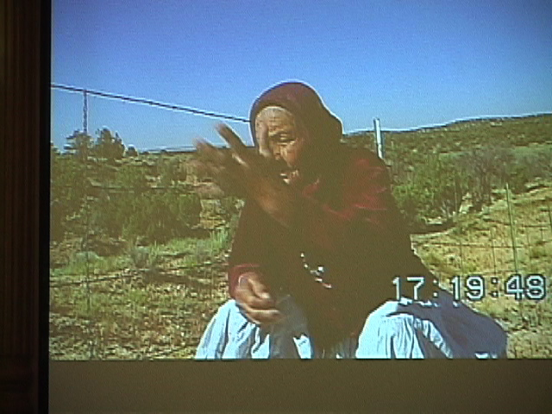
Its like they are just eating all the things they are taking out. We understand as indigenous people that all the things that are taken out are precious things. But it doesn’t mean that we should exploit it. They are precious. They are sacred. They all have to interact amongst themselves in order to provide us life. The Navajo Nation government are supporting expansion of the mine. We heard that they are in agreement with the coal company. This collusion will continue to affect the water. “For many years I have lived next to a big canyon. And in the bottom of the canyon there was a little stream that flowed year round. Now I take the sheep down there and there’s nothing. Nothing’s flowing anymore. Its’ been like this for several years now. The seeps on the side of the cliffs have dried up. A lot of the natural springs too. There were places where you could go and just dig a few inches with your hands and water would start coming out. Now you go there and there’s nothing, just a basin with dry clay. Where several years ago there was a clear blue pond, now there is a cracked, dry dirt. This is how we are seeing it and we are witnessing the effects of what the coal company is doing. The mine has to be closed. The mining has to be stopped. Yes there is employment. Yes there is wealth in terms of money. There are jobs that are gonna be lost. We understand that. If our communities could be more innovative and creative we could create other jobs that would fill this need rather than just go on butchering the mother. With the mine we continue to allow Washington to rule us, and let ourselves think that that is the only brain that we can live under. This is not so. They are robbing us of our children as we go along blindly with their plan about the coal. Sending them off to fight that war. This is what they have done to us and what they continue to do to us. So we should put an end to this mine, I think.”
That is what Pauline Whitesinger wanted to say here today. Thank you.

RENA BABBITT LANE, Naakai.
D77 yee’ kod00 had77dzih shi’di’n7igo haasdziih, sha’1[ch7n7. 11d00 sits00k4 danoh[7n7g77 sh99 t’aha[d88h. K0on7 bee sit’4ego t’4iy1 Dzi[ Ijiin naaznil. T’11 7iyis77 doo b0hon4edz32 da, 1k0t’4ego. Nihida’dii[‘1 ts’7d1 t’11 1wo[7 bee. Doo l1 d0’ doodah1gi 1t’4ego nihidaha’1a bilag1anaa woly4e. Doo dajijooba’da. Nisin. Biniinaa doo ashoshg00 niyii[kaah. K’ad d7kw77 sh99 n1hai, t’11 1k0t’4ego. T’11 7iyis77 bi[ de7n7iikeeh. Ha’1t’77 l1 y0w44 1t 4ego, t’11 siz99d00, doo 1di[ danidl99g00 Diyin b7dahwiidla da nisin, Bilag1ana. Bee 7zhdiits’a biniiy4 t’4iy1 hw44n4est[‘in sh99. Hatsiits’iin doo han11 d00 hach99h $7 sh99 bee din4 jin4[‘98go nabik’ints7dz7[kees [eh. !koho ts’7d1 t’11 1wo[7 bee doo dajooba da. H1 1t 7i da y0w44 1t’4ego. !adi na’iiniit’4ego t’11 a[tson7 dabinish[1. !ko hait’1o doo hojooba’ bee nihaa nts7deiikees l1 nisin? . T’11 aan77 47 hane hane’d66 d77 yich’id7g77 47di7g77 t’11 aan77. H11l1 k0on7 baa n11da’ayiizniih t’11’akw77j9. B22hd66 47 n7saahiits’a. Nihee daats’I nahodoo[t88[ 7l98go. Choo’99[ dan7il’98 [eh dzi[ nihidziil. Nihim1. T’11 1n0ht’e nahasz11n woly4ii nihim1 1t’4. T’11 1niiltso sh99 bik11 diid99h D00 t’11 aan77 47 nih1 a[tso. D00 t’11 aan77 t’4iy1 bik11 k’44da’diily4ego kod00, y1’1t’44h, ch’iy11n woly4ii bik11 h0l=. K0on7 k0t’4ego k44hwiit’9. {99 bik11g00 7nda t4lii. K0on7 47 chid7 bi[ danizh0n7 yee n0. $7 chid7 y65 nih22h adajit’9. !1d00 4iy1 Bilag1anaa t’47y1 deidiits’a’go 1dajiilaa. !ko 47 k’ad 1[ch7n7 y65 doo nihidiits’a da daazl99. Doo danihidiits’a da. T’11 ak== k== shim1 yaa hoolne. ‘!ts4 bim1 haaghal, bizh4’4 haaghal [eh,’ n7igo ts’7d1 t’11 aan77, t’11 1k0t’4. !hoot’4ego 1hoot’4.
$7 d77 dzi[ nihin1znil7g77 ts’7d1 ay0o ad47n77’n7igo nihin1znil.
K’ad 4iy1 t’1adoo biniiy4h4g00 t0 nich=’= hadaazl8’7g77 ha’1t’77 biniiy4 1adi t’4iy1, ha’1t’77sh bee baa n7zhdiikai? T’11 aan77 7iyis77 hanii doo nts7dadzikees da doo 1hojily32 da. Dzi[ hooly4ii ay07 0’n7inii 0oly4. T’11 a[tso bich’9 diyinii b22h h0l=. Bee nahagh1h1 a[tso b22h dah0l=. !1d00 7nda, “h0zh= naash1a doo” ha’n7igo bee n11’da’iiniih, 47 biniinaa t’11 7iyis77 nihida’dii[‘1h1 bee nihida’dii[‘1. Nih22h dah nahas’3 hojoob1’ nts7deiikees. K0t’4ego 1t’4 sha’a[ch7n7. Haash99 nohsin. T’11 aanii 1t’4. H17sh 47 doo adeesh99[ da n7zin? Ts’7d1 t’11 1niiltso da’diid99[ daniidzin. Ajiy99hg00 da ho[ h0zh=- [eh. J0, 1k0t’4ego’1t’4. !k0t’4ego hadahidoohdzih nihidi’n7. Da’77s0[ts’33, haash woly4ego 1ch’8 y1ti’doolee[. A[ch7n7 woly4ii t’11 7iyis77 doo nihizaad n11dabizaad da. T’11 din4k’ehgo dabizaad dah0l= t’11 y1’1t’44h doolee[ sh32, n7. Dib4g00 nji[‘1h32 doo bi[ b44hozin da [eh. Koj7g0 dib4 iik11h, j0 yits’32jigo de7lwo[ [eh. K0t’4ego 1hoot’4. Haal4it’4ego 47 n11s yiikah doolee[go 1t’44 l1? J0 t’11 aan77 1k0t’4. Ts’7d1 t’11 1wo[7 bee ts7st[‘aho’diniilkaad ha’n7n7g77 t’11 aan77. !k0ne yiikah. !k0t’1o baa nts1h1kees.
!1d00 7nda s1anii y65 t’11 77yis77 nihits’33 bita’hadl11h nahalin. Hast07 y65 1k0t’4 nihits’33 an1h1k11h. Haash yit’1o 47 din4 sh2’ 47 dood88[? Din4 hast07 t’11 dah0y32nii y65 nihits’33 1din ndahaleeh? H17sh 47 bil99 an11hidoot’11[. !ko t’11 77yis77 t’11 hazh0’0 doo y1 1sh=- da.
&nda t’00 da’jilzhish Ts4gh1hoodz1n7di nihinant’a’7 shij44. T’00 ha’1t’77sh99, t’00 din4 t’11 1dzaag00 da’an11di’niilzhiizh ha’n7igo. $7sh biniiy4 t11 naaznil7 dajil9. $7sh biniiy4 h1 n11da’diyii’nih ![ch7n7 ga’ nih1 ndazh’nitin doo biniiy4. T’11 1wo[7 bee t’4iy1 1k0t’10 baa nts1h1kees. N11n1 1kwe’4 47 k0on7, sh7 47 doo ha’1t’4ego da 44hasin da ndi shizh4’e 47 y1’1t’4ehgo deiikai, nl47d66. Ts’7d1 y1’1t’e’4eho hast07 y1’1t’4ehii danil98go bits’33 da’ad3 bil99 dah0l=-go, nizh0n7go din4k’ehj7go nihidi’n77 l1go baa 1kodaniidz99. Ha’1t’77sh99 hait4ego dildeeh, t’11 77yis77. T’00 haash99 1t’4. D77 yigh33 47 Kiis’1anii, ha’n0. Da’ Kiis 1anii7sh Din4 1t’4? H17sh 1biilaa? Had66sh99 doo b44hozin7d00 hazl99. Bahane ndi doo b44h0zin da. T’11 bin11[ hane’7g77 din’4kehj7 dah diijah. K0t’4ego 47 baa nts4skees. T’11 k0n7[tso’go daats’7 nihits’33 asd99d doolee[. D77 dzi[7g77 ts’7d1 t’1adoo nihits’33 baa ]dajit’7n7 doolee[, dooda. Haash yit’1o t’4iy1 nihee n11hodoo[t99[?
Haash yit’1o t’47y1 bits’33d00 naha[tin? K’os da’ilts’o’0 11d00 nizh0n7go ndaha[tin, a[k’7d33 doo baa hwiinit’99d33, doo hadaasgeed33. K’ad 47 hadaasgeed, [ahg00. Ei biniinaa doo n7 daats’7 1hee[t’44 nahalingo nihee naha[tin da. K0t’1o 47 baa nts1h1kees, 1ko 11d00 ak== deis0[ts’33 doolee[. A1d00 bik’eh 1danoht’4e doolee[. T’11 47 nihits’33 1sd99d dool44[.
She wants to thank everyone for coming to this meeting. Some of you might not understand that the Traditional People, the Dine, especially like the one we saw in the video and like Rena, they like to greet everyone as their children. Because that’s just how it is. No matter what color you are. This is how she’s addressing everybody this afternoon. “Welcome my children, and for allowing me to speak before you, and to listen to what everybody has to say, and for what I have to say as well.”
She really wants to just talk about what happened since she’s in Flagstaff. She wants to talk about the Mountain. But also, she is from Black Mesa, She’s also been affected by the relocation policy. She wants to say, what her mother, or her relative Pauline Whitesinger has said, is the same thing, the same kind of way that she lives as well. She wants everybody to realize that. That she agrees with what Pauline has to say. And this, looking at it from a traditional point of view, you start asking yourself, “this white government, their laws, it’s a law that doesn’t care about life. It affects life, instead of caring for life. It affects the old people, instead of making them live longer. It affects your dreams, instead of sleeping peacfully at night, and having your rest. So it affects everything in every way. The relocation, the desecration of the Mountain here. The Mountains are important to the Dine people. When it’s abused, that’s abuse to our Prayers, our Way. Just as it has been said, they have been digging into our Sacred Medicine Bundles, our belief system. They’re digging in there and distrupting the order of our Ways. The reason why this mountain is special to us, is that we make offerings to the Mountain. That we call her our Mother. And also, she represents the Mother Earth. This rain, the moisture for the earth, for the land, we need to all see, be on the same level, realize that we all need Her. We all live on top of Her. Underneath Her. That She nourishes us, all of us. She does not discriminate. She provides everything for all of us. All the rain drops and all the rain is provided for everybody. And then in turn, we live off that nourishment. We grow crops. We gather medicines from this. And some day, all our children will be needing all these resources, all these connections, to the Mountain.
And our language is very important as well. And I want to repeat what Pauline has said, my mother, she stated everything so clearly, about the language, how concerned we are for our language. That we’re losing it. And I also want to say again, the use of waste water to make snow, is the lowest way of thinking that any human can have. How can anyone think that way and be considered that they have the best idea? They have the alternative idea? This is just the lowest. It is disrespect to many nations as well. A disrespect to the Indian Ways, their Songs. And also to the beauty of the land, the forests, the peacefulness of the woods and the environment. It’s also harmful and destructive to the future and the Children. They deserve better, instead of what has been proposed. It is going to be more damaging to them.
And I would ask you my children to see this. To think about what is being said, What we’re trying to share with you. We have travelled a long ways to share this with you. And to realise that we are all the same, we are all one People. We all like to indulge in something that we like. We like to expect good things in the future for our families. We are the same. We are no diffferent. Let’s stop the abuse. Let’s stop the discrimination, and the racism that exists. We need to realize that we are all the same. We all have something we look forward to having. We should look forward to having children, our future generations. And that is most important, what we are going to provide for them.
And the only thing you think of is extermination of your community, of your culture, of your being. And then, at the same time, we see that all the old ones are gone. We all grew up having all the very old people living with us, dying of old age in our community, instead of else where. So this is what’s gone. It is true what has been said. And so I ask also, How do we revive? How do we replace what we have lost, what has been taken from us? The wisdom, the knowledge? How can that be revived? I ask those questions.
So the Tribal Government in Window Rock do not really support our efforts, or their People, and their struggle to stay on the land and maintain their culture. What they’d rather support is to exploit their own people, to exploit the Dine culture. To have song and dances, just to put on a show and say how great we Indians are. And they don’t want to put a lot of effort into what we are facing out there.” She thinks that the Navajo Nation Government is for some other purpose, not for the purpose of improving their Nation and the quality of the culture.
She says that in the beginning it was good. When she was a little girl, things were very different. 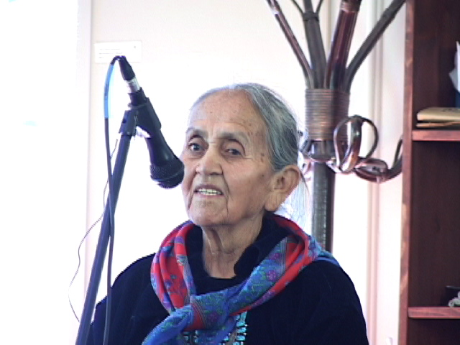“The kinship system was so strong. Now the land problem, the relocation problem has come about. And what is being said out there in the media, what is being put out to the public, is that the reason why this mine issue, the relocation is taking place is because the Hopis and the Navajos are fighting against each other. And the Government had to provide them land. We need to see that that’s not so. And they’re using it to cover up in order to attack us, when we are isolated. So this is what’s happening. I ask you to see that, to understand that. The Hopis and the Dine’ have never had any problems over land. They have never had any problems over land issues.
And so the last thing I wanted to say again, to leave you with, is that this mountain should be left the way it is. Not to be desecrated any more. We need the clouds on top of this mountain. We need to put thunder clouds to form up there, to spread the rains throughout the monsoon. This is the way it was before they started desecrating it. Many things have changed since they started desecrating this mountain. So please hear us and let the Mountain be. I ask you please to listen to those who are trying to protect the mountain, and to protect the water up on Black Mesa, making efforts to protect our land, our culture.”
Thankyou.
NORRIS NEEZ, hataa[ii,
Y1’1t’44h. Kwe’4, a[ah noh[7n7g77, 47 ye’ a[ah noh[7n7g77 t’11 1no[tso, ah4hee, nihid77niid doolee[ kwe’4 a[ah niidl98 d00 ah7ikai. T’11 akwe’4 sh99 d77 sh7 d77 T0naneesd7z7d66 naash1. !kohgo sh99 t’47 Din4 woly4h7g77 47 nish[9. !1d00 d77 daash99 n4el33 din4 doo t’11 kin[1n7digi kwe’4. !1d00 ah4hee, nihich’8 haasdz7h7g77 sh99 deis7n0[ts’33 d00 shik’eh adadoodl77[. Dash77sin0[ts’33 d00 ah4hee, shik44 ]dookah 47 sh99 biniiy4 ah7ikai. !ko d77 biniiy4 kwe’4 n7y1h7g77, 47 sh99 nl47 dahane, D77 k’ad dahane’7g77, 47 sh99 t’11 1t’4 shi[ b44hoozin. J0 1kondi, t’11 1doochi[go t’47y1 b7ighah k’ad nl47 hodeey1 hooly44d66 k44hwiit’9. D77 a[tso n11haigo 47 t’11 k44hwiit’9. Doo 47 1niid nihits’33 1niit’4e da. &7shj33 1k0t’4. $7 bee nih44honohsin. D77 kwe’4 dzi[ si’1n7g77, 47 d0’, t’1adoo 47y1 b7ighah1 b44h4g4eh7 doolee[. !ad00 47 t0 nchx=’7g77, 47 nib44h4geeh doolee[7g77 47 dooda. Dooda daniidzingo bee nts7deiikees. D7kw77sh99 1k0t’4 dzi[ hast33 sinil 1k0t’4. $7 baa 1konohsin doolee[. !1d00 t’1adoo bahat’aad7 dzi[ nizh0n7go si’3. !noolningi 47 din4 sid1ago 1t’4, 47 hazh0’0 baa 1konohsin. Nihinant’a’7 1t’4, d00 nihim1 1t’4, dzi[. D77 naat’agii nil98nii 47 t’00 ahay07 yik11 na’aldeeh. T0 t’00 baa’iihii dayoodl32 doo dab7ighah da. T’00 ahay07 dzi[ b22h h0l=. !1d00 b88h 1daat’4ii, d7kw77sh99 ndaaldloshii t’00 ahay07 yik11 da’adl3 d00 yaa ndaakai 47 biniinaa dooda. !1d00 t’11 nih7 d0 11d00 [eeh y7l7n7g77 nl47 adahwiis’11g00 ndaazl9 t0 danil7inii, t0 dan7l7ingo 1t’4, d77 4i b22 kwe’4 y1’1t’44hii kwe’4 t’47y1 47 doo nihi[ y1’1daat’44h da. !kwii y0wehdi’ 1t’98 doolee[, t’11 1niiltso, 77shj33. Y0wehgo y1’1t’44h doolee[, 4id7. $7 1k0ni[tso’go bee nihits’33 haasdziih doolee[. Y4igo 47 77shj33 ]diik11h. Dooda doolee[, 4id7. Nich=’= b44h4geeh7g77. !koho ye’7inisin. Kod00 bits99g00 k44dahoht’7n7g77, nihik1 dadaalgai7g77, ah4hee. Bich’33h ]diikah. T’11[1h1di t’47y1 t’11’77d33 baa hwiinit’98go hazh0’0 nihidziil si’3 bits99g00 k44dahwiit’99d00 k== ]deiikai. K0t’4e doolee[go t’4iy1 nih1 baa nts4skees d0 nts4skees kwii 1t’44 77shj33 baa 1konohsin doolee[. !1d00 d77 1koni[tso’go koj7, nihi[ ch’7hon7’32 doolee[.
!1d00 dzi[7g77, din4 1t’4, 47. Diyingo 47 si’3. Doo 47 t’00 dzi[ 1t’4e da. Doo 47 t’00 baa honeeniidgo be’1d7l11h biniiy4 si’32 da, 47.
This mountain, it is a person. It is sacred. It is not just a mountain. It does not exist for the purpose of entertainment.
!1d00 n11n1, d77 koj7, nihosdz11n bik11g00 1t’4h7g77, 47 Shiprockj7 nihi[ y1niits’ee 1daalne, t’00 ahay07. $7 d0, y0wehgo y1’1t’4eh doolee[. $7 doo n11doot’1a[ da, nichx=. D77di dooda nish[=- n7y1. !ad00 h1adida, t’11 1n7iltso nihiyi yikaigo doo ashdlee da. J0 nih7 k’ad 1kwiidzaa, nl11hdi. Din4 bij47 b1 ]daalgizh. !k0t’4ego k44hwiit’9. Nihij47y65 binda’anish. K0t’4ego t’4iy1’ nihij47 handa’ha’n77[. K0t’4ego 47 bik’eekai yiikah. D77 k’ad Dook’o’os[77d bits99d00 n0wehj8 doo ts’77 at’44 da hoogo[ [id woly4eii doo b44hozinii bilid bii k44hwiit’9. D7igi 47 biniinaa. D77 b44sh bii k-‘7tsoh diit’1h7g77 dooda doolee[. T11 nl47 d7kw77go sh99 sinil. T’11 1t’4 47 [id dahooldooh, chid7 bit[‘id 1daat’4ii. !1d00 chid7 naat’a’7 bit[‘id 1daat’4eii 1dahooldoh. !1d00 t0 ndahodiilkeed t’00 ahay07 [eeh dahooldoh !1d00 d77 bee nda’dilt[i’7g77, k0on7, a[’33 1t’4e dabilid h0l=. Nl47d66 47 1din nt’44. Kwe’4 47 baa nts4skees doolee[. Eii yee’1adi7g77 nchx= doolee[. Doo b44sh bii k-‘7 ]doot’11[, Shiprockdi7g77, 4id7 dooda doolee[. D77 47 hadeesdzihgo biniiy4 n7y1. Shidin4’4y65 [id bi’niigh33, t’11 1wo[7 bee [id bik’ee t7’dahoo’n7i[go 1t’4. $7 b22 y0weh doolee[. !1d00 t0 deiidl3n7g77 a[tso t’00 baa’ iihgo daazl98go 1t’4. !1d00 d77 k’ad [id woly4e bi[ nanih7daaldooh nihits’77s65 daneezgaigo 1t’4. D77 tsint[‘1ahgoo kodi [ahgo 1t’4 honeezk’1z7 din4 k44dahat’9. Kodi y65 t’4iy1, doo 1k0t’4e da. !ko d77 k’ad haash99 n7zahdi k44hwiit’99 nt’44, ah44hosiilz88h, d77j98di. Bilag1anaa woly4ii 47 nihaa n7y1 d00 bi[ k44hwiit’9. !ko a[n77 bil11h din4 bi[ y1’1daat’44h, 11d00 [ahj8 47 doo 1t’4ego nts7daakees da. Kwe’4 1t’4ego 47 k’4. !ko 47 t’4iy1 nihits’33 hadeesdzih biniinaa. 1ko ah4hee, t’4iy1 nihidishn7i doolee[. !ko d77 ye’ t’4iy1 biniiy4 dooda dadii’n7i doolee[ nih1 nihi[ ch’7honi’3n7g77 biniiy4 n7y1. Ah4hee.
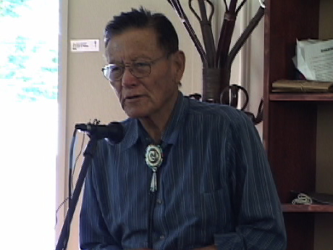
He said, “I’m from Tuba City and I also belong to the Dine’ population. I came here out of great concern and also to share just a few things with you in regards to what is being discussed here, sacredness and about Indigenous culture, the environment. I want to say that my ancestors have not come here recently. Myself, I was priviledged to learn about the ancient ways and the Dine religion. This knowledge was not thought up recently, it goes back to the beginning of creation, to the very beginnings of when humans were allowed to live on this earth. This is my background. Based on that I want to express my concerns on the issues that we are facing today. This religion really relates to the natural environment, what we see out there as soon as we go out this door or leave the city; everything that we hear or see or smell out there, that is the natural world, that is what our religion is relating to. Look at this mountain here, Dook’o’os[77d. the San Francisco Mts. Look at, and think about it and know, and understand that it is not just a chunk of rock. It is not just a huge pile of dirt or a mountain. Think of it as a being, as a living, breathing, thinking being. In there it has a consciousness. Try and think of it in that way. It does not stand there as a commodity to be used or as something there to be enjoyed as entertainment. It is not there for your indulgement. There are many species of birds that land along the mountain. Some walk and graze there. Some crawl under the bushes. All of these will have to someday drink the water. If it is contaminated, that is what they will drink. The water will go into the ground and travel far. Someday we will start drinking it as well. So this is why I ask on behalf of all the others that are working very hard to stop this proposal, please consider to help stop this construction and the pumping.
I want especially to thank each and every one of you my white relatives for coming here and trying to understand what is being said here. This is your mother earth too. Mother Earth faces many problems today due to the pressures of progress. Within the Navajo Nation they are trying to build more power plants today. If you want to know what the coal fired power plants are doing to our people, all you have to do is go to any Indian Health Services clinic and see how many Dine and Hopi people have heart problems, or problems with their breathing. They’re having a lot of surgeries on the heart. This is coming from the coal fired power plants. We have too many of them on the reservation already. But we have nothing which can replace those damaged hearts. This is what I see. Our air is already full of petrochemical exhaust, from the cars and the jetliners, and even the different sorts of lighting that we have here. Its all been polluted now. I’m just a simple person on the reservation, but I visit a lot of people and hear their stories around the reservation. The air has enough of this junk in it so let’s stop the power plants and protect the waters too. We need to say “NO” to these things! Thank you again for hearing my talk.”

LEONARD BENALLY
Ya’at’eeh. My name’s Leonard, I’m a Navajo from Black Mesa. Big Mountain.
I am here today because I have a great concern. And so for some of the people that are living out on Big Mountain. HPL side. Because not too long ago here, John McCain came out with a bill. Its called Navajo Hopi Land settlement act of 2005. So, we are still threatened by these things. They still want to force people off the land against their will, against their wishes. And at the same time, we are impacted by this environmental imapcts that you hear people talking about. But at this moment, I’m gonna be talking about the human impact here. This relocation started about 1974. That’s when people were forced to move off the land here. For greed. And to this day they’re still doing it here. We know, and I know deep down that the relocation is against U.S. policies here. But for us people, the inhabitants of Black Mesa, we’re still being told that, “You must move off your ancestoral land”. But they don’t look at it this way, but this is how we look at it. But they want to still clear up everybody by October 2006. And they want to close the book on this whole thing, on the relocation here by 2008, September 30. And John McCain says in this bill that he’s just gonna close this book and it’s goona go quietly away into the night here. But as you’ve seen some of the elder people here, they were talking aboutu these things. They were talking about the impact, the atrocities here of the relocation. And a lot of people died from this thing, out at Black Mesa. Just because the US can produce more energy here. The people were sacrificed. And to this day some of us are orphans out there. We lost our mothers, fathers, brothers, sisters, relatives. And its still going on to this day. But we’re saying, “enough!” to these things. In my time, I seen a lot of deaths out there. So yes, they sacrificed it. Poor people. And these are the indigenous people of Black Mesa. Just so some person in Los Angeles or Las Vegas or even the Phoenix valley here can have a air conditioning or electricity. And you see all those electric lights in Las Vegas or Laughlin, Nevada. That’s our wealth, that is our product here. And I myself don’t have a running water. But I’m not asking for it here. And I don’t have electricity.
They want to come in and still exploit the people. And right now, the exploiteds are not happy these days. So enough to these things.
And here, at the end of next week, some of us are gonna go down the road. And some of us have already burned our ships. We’re gonna go down these one-way roads that does not permit no return. Because now we’re asking for solidarity, support from the people. So we can say ‘enough!’ to these things. And no more genocide. This is still going on out there. Ethnic cleansing. And the Navajo Tribal Council and the Hopi Tribal council, they’re participating in these genocide. And they got blood stains on their hand, off the Black Mesa people here. July 18, we’re gonna be taking our message here to Window Rock. That ‘s where all the leaders are at. And we’re gonna tell them, “ENOUGH TO THESE THINGS.”
And yes I’m deeply disappointed too, about what they said about the mother mountain here, the San Francisco Peaks. Because she’s the only thing. She’s the only one that we have. And we’re still resisting. This is the only inheritance that our ancestors left us. And we’re exercising to these days. And yes, Navajo people were put in death camps. By the government, US government here. This happened in the 1800’s, 1860-1864. And after the peoples were released they said “no more” to these things. But this is not our law. We don’t make these laws. The people that make these laws will usually be the first ones to violate them too. To this day there are only a very few people out there, only a handful, that are resisting. To oppression, from the US govt. here. And from all these energy companies. And thank you. For now that’s all I say.
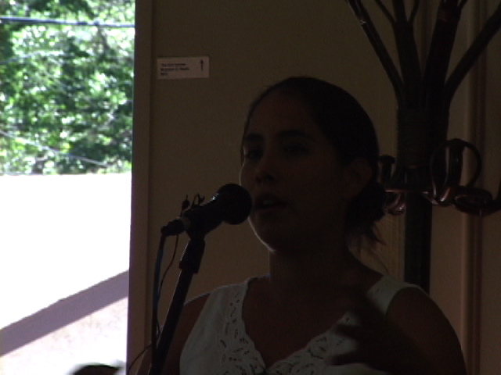

INEAI BEGAY, Black Mesa Water Coalition
Y1’1t’44h. Sh7 47 Ineai Begay dashijin7. T1chiinii 47 nish[9. T0 d7ch’7inii b1 sh7shch77n. TohanaOdahm 47 dashicheii d00 shinal7.
Hello, my name is Ineai Begay. I come from a community on the reservation called Shonto, which is just off of Black Mesa. It is actually the place where the N-aquifer replenishes. I grew up in Kayenta, went to college in California and now I live here in Flagstaff. I’m a member of an organization called Black Mesa Water Coalition, and I’ve been asked to say a few words about it.
Black Mesa Water Coalition started out as one of the first Navajo and Hopi organization of youth out there working on the issues. All of us are from the Black Mesa area. We’re seeing the effects that this coal mine is having on our family and feeling like we didn’t have a voice as young people. We started organizing meetings on the reservation, going to the Navajo and Hopi Council, and working with the other organizations out there, Black Mesa Trust and T0 Nizh0n7 !n7.
Now we work on many different issues that relate to Navajo and Hopi. But our motto is, “empowering young people about building sustainable communities”.
We do advocacy work, lobbying our tribal governments but also do things like earth building projects out in Hopi, teaching people how to build homes out of cob, trying to get communities to take on renewable energy projects. We do a lot of youth leadership development, bringing in a lot of Navajo and Hopi children and teaching them about what are the political systems that we live in righth now. What are all these big words like globalization, how can we live more sustainably and in line with our cultural values?
By using earth-building, or collecting rainwater. And trying to make the connection with people that in our everyday life, by opening the refrigerator or turning on the lights, that everyday thing is what is manifesting on Black Mesa. That is the impacts that are happening so we can turn on the lights or the refrigerator. Making that connection with young people as well as people in California who are receiving all the coal and all the water from Black Mesa. Southern California gets the majority of the electricity from Black Mesa mining.
There are about 20 active members of the Black Mesa Water Coalition. If you are interested in learning more about our organization, we have a website and a phone number that’s on the website. www.blackmesawatercoalition.org

KLEE BENALLY
Y1’1t’44h a[t1has88[g00. Sh7 47 Klee Benally yinishy4. T0 d7ch’7inii b1 shishch77n. Naakai dine’4 dashin1l7. Dzi[ &jiind66 naash1, Kin[1n7di shihooghan.
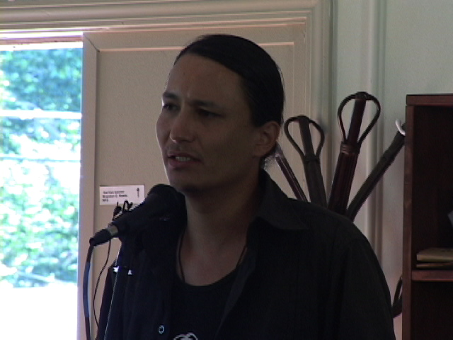
My name is Klee Benally. I’m a representative of Indigenous Action Media, an organization. We do media justice work, trainings for youth in coverage of issues just like these in our communities. I’m also a representative of the Save The Peaks coalition. We’ve been advocating for the San Francisco Peaks, for the environment, for the cultures of thirteen tribes to be respected in this community and by the Forest Service in their decisions….
Our lifestyle choices are connected to this. Every example of the sorts of struggles to fight globalization around the world are also condensed here in Northern AZ. The water issues. Privatization, Resource development. Denying us our own self-determination…
The San Francisco Peaks is one of four sacred mountains for our people. Actually, one of six, one of the four cardinal mountains. And it was explained to me by my grandmother that in the center of these four cardinal mountains is the Altar, where the patient sits to receive the medicine. That altar is Black Mesa…
We’re not here to dishearten people. We’re here to communicate that we are all part of the solution in our choice to take action when we see this type of injustice happening….
Our council has made very strong statements to protect the Peaks, saying that the use of wastewater is an act of cultural genocide. But there is a double standard there when they will not honor and protect and make the same strong stand to protect the people and the environment of Black Mesa…
We cannot compromise. We cannot protect one sacred site and then take the money from the desecration of another one…
Snowbowl is already cutting trees. We have maps on the website that are monitoring these activities. This is happening and we need more direct forms of action here. Thank you.

www.savethepeaks.org

LOUISE BENALLY
Big Mountain
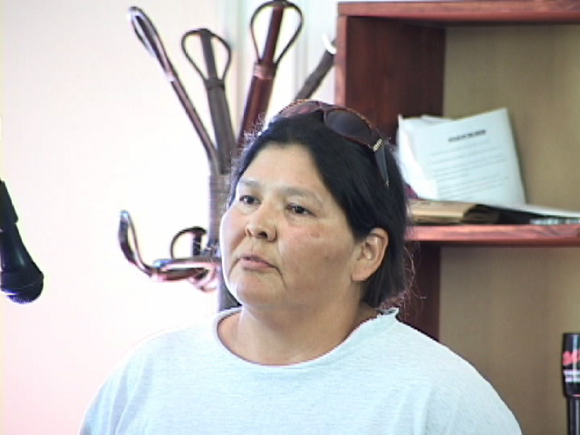
Ya’at’eeh doo ahehee. Thank you for inviting me here. I really don’t have a whole lot to tell you other than the struggle of Big Mountain, we’re losing people left and right for the last few years. Most of our core leaders are now gone. However the work that they’ve done on behalf of the sacred sites continues each day as we live there. We don’t really have a lot of choice because the majority of the people sold out to the Accomodation Agreement. Once that happened, they gave jurisdiction to the Hopi Tribe. And the Hopi Tribe is only focused on greed. Their only interest is money. And that’s why they’re a “Hopi Tribal Government”. And the Navajo Tribal Government. They’re all in bed with Peobody. Talk about gay marriage. So that’s like a big crime, being committed upon us, and yet we’re being punished for who we are just because we want to live simply our way of life. There are not many of us left out there that are so-called ‘resisters’. We’re just simple human beings that try to live day-to-day based on our traditional philosophy. As we speak here now I can say that there are 5 homesites that have never agreed to this so-called accomodation agreement. And now the Navajo Nation is only soliciting more money to make and finish homes for those people who have made an agreement with the Hopi Tribe. So we are faced with a lot. Many many people across this country and even in this community claim to be helping us, but we don’t really see anything. Other than hardship. And struggle. We don’t have water. We don’t have home improvement. So I would like to ask Black Mesa Indigenous Support group to focus on those non-signers, and do something for us for real. Don’t just come out there once in a great while maybe once every two or three years and claim that you care. And then go back to your cities. And we don’t know. We don’t know what you do, we don’t know where you are. So this is where we’re coming from. We have been attacked in 2001. Our ceremonial site has been destroyed. Out of that we have filed a federal suit that probably won’t go anywhere. But it’s just one thing that we have to do. We know that we will not easily let go. And we know that our homeland is where our fathers are now dust, and our umbilical cords are part of that land. And they cannot deny us this. If there can be justice for people in Palestine, there can be justice for people in the HPL. Please support us in our struggle. We do not have a website. And please do not take advantage of us. Whether you go out and write grants, get equipment, saying that you’re gonna help these people or this is theirs. And then put it out for sale, on your web page. We never hear back from you. Don’t do this to us. We’re already sick, we’re already tired, we don’t need more of that. Please understand that. Thank you.

FREDERICK SHERMAN, Naasht’ezhi t1b22h1, bf To’d7ch’7inii…Teacher of Environmetal Science and Natural Resources at Crownpoint Institute of Technology.
“Sh7 4iy1 shizh4’4 nl47 ts4k-‘7 hadaasgeedj7 atah naalnish. D00 47 ts4k-j7 haag4d7g77 yits’33d00 yilnish7g77 bits’33d00 sh7 1n7sht’4. D00 47 shiyaa hoo’1… “Azh3 t’00 baa iih7g77 t’47y1 baa neiikai bits’33d00 nizh0n7g77 1dadiiln77[, nih7 sha’1[ch7n7” nihid77niid, nihizh4’4.”
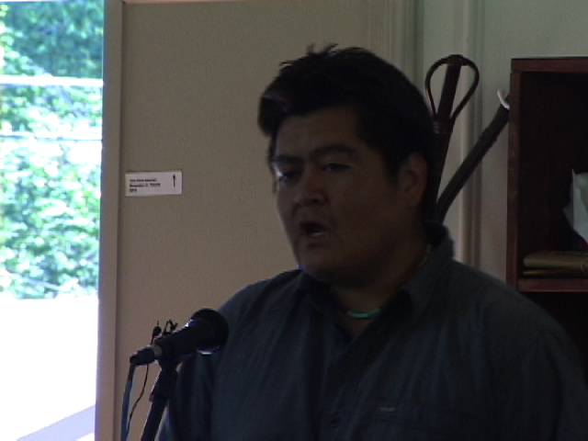
My Dad works at the Black Mesa Coal mine and I am a product of that mine. My father paid for my education with his salary. He told us that “We are doing a terrible thing. We are desecrating the female mountain. We’re taking her liver out. I know that it’s wrong but try and make something good for yourself out of something that we’re doing wrong to our own people.”
“These things I say because I’m looking at things from a scientific perspective…”
“Some of these lifestyles, they know conservation methods. And they look poor, they look primative. But in reality they’re the richest. Because they got family unit and they know how to make an honest day to day living.”

MILTON NEEZ, Tuba City
“This is something they’ve been talking about. Look at all these power plants here. Plus Page. What kind of air pollution are we getting here? We’re suffocating…
Leupp. Its right here. There’s one of the precious and the very clear water. Look what they’re gonna do. They’re gonna run it up to Black Mesa and then all the way down to Laughlin with the coal. This is what they’re doing…
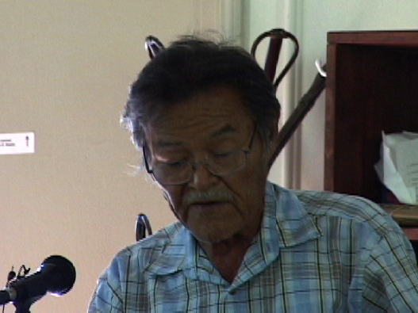
This is the survey that they’re doing up there. See this? Sinkholes. That’s been verified by the scientists its because the waters been taken down too low.”
Now, with the Peaks, it’s a very common sense. They all say, the medicine mans, the sheepherders they all say, “Please. Don’t put the dirty water up on the mountain.”
The money? That’s what I know. They’re comparison it and sayin’ ‘woah! We’re gonna be rich if we can put the snow up there!’ That’s what’s causin’ it. So we need some kind of a help from the public to put a stop to that one.

NO NAME, Lawrence, KS-Iowa Nation
Relocation happened for my people a long time ago… For the past 20 years there’s been an attempt to build a highway through some wetlands near Haskell Indian Nations University which was started in 1884 as one of the assimilation boarding schools run by the BIA. It has since become a full four year University. The wetlands were at that time a place where kids could go and speak their language and practice their traditions, do their ceremonies without the fear of being beaten or whatever else was going on at the assimilation schools of those days. Through a series of shady events the land was transferred over to an entity that would begin building a superhighway through that area as part of the Rt 35 corridor which runs NAFTA trade from Mexico through all the way to Canada. You can imagine what 8 lanes of highway will do to the wetlands and the wildlife there. These are symptoms of a culture that has no roots in any particular place. So Indigenous people have that connection. It seems to me that wherever that remains we need to do whatever we can to protect it. Since I’ve been out here I’ve been staying with an elder on the HPL. All of her stories take place right around her house. 75 years of stories about right there. So let’s keep it up and see what we can do.

A TRADITIONAL HOPI SPOKESMAN, Hotevilla
I’m glad that everyone was interested in coming here today. I hope that we can leave here with good thoughts and get together like this closer to home. I agree with everything that the elders have said today about the mining and other dislocation. We’ll be working together.
The Hopi elders have been talking about these things all these years. Unfortunately there’s not many of us left to speak of these things. But hearing what the elders had to say, this medicine man here for example, it made me feel real good. I thank you all for being here.

RENA BABBITT LANE (NAANA-conclusion)
N!!N!
Y1’1n11n1t’44h, sits00k4. !koho t’4iy1, nizh0n7 yee 1adi neiikai. Inda 47 k=-di nihin11[ y1d11ti. !ko y4igo baa 1kodanohsin. T’11 shoond7. T’11 aan77, 47 dib4 dib11 nihits’33 dabi’niigh33, 7nda [99 da. Ts’7d1 y47go baa hin1n7g77 1t’4ego. T0 77l7n7g77 47 a[tso 77l8 ha’n7. $7 t’11 aan77 ha’1t’77 dooz1agi y65 da’7l98 doolee[? !ko din4 k0n4el33 k44hat’98go bitahd00. $id7 ts’7d1 t’11 77yis77 h1ajish99 77l9. &nda t’00 ahay07go h11g00sh99 [eejin hada’ageed. !ko nih7 47 nihighandi a[tso ndahalzhaazh. Inda n11d8’7di d11d7lka[ ndi t’00 bin7k1 dahasz11ngo 1k0t1o k44hwiit’9. !ko ha’1t’77l1 y0w44 1t’4ego, nihij47. Dadits’id da’7l9, doosohodeeb4ezh da. T’11 77yis7 baa hin7n7g77 1t’4ego k44hwiit’9. . Ts’7d1 t’11 aw44 a[ts’77s7 yee k0ni[tso’go biza’jiin7i[ nahalingo sh99 nahasdz11n nihiza’da diin7i[go 1t’4. !ko y47go baa nts7daahkees, sha’1[ch7n7. T’11 shoond7. Ham1 woly4ii binahat’1 d0 bij47 t7’d7l’98go h0y44 sh99 t’11 aan77. J0 k== nihiz1anii nt’44 1daadin. Nih1 y1daa[ti nt’44.
K4yah woly4ii. T’11 1niiltso bik11 daniijah, d00 t’11 1n7iltso 47 bik11 da’diid3. T’11 1n7n7gi 1t’4ego da’iilgh11sh [eh. !ko t’11 77yis77 nihim1 1t’4. Doo t’00 sha’shin da.

!ko t’11 dikw7h7 yee t’11 diniikw7h7 yee diidziih. &nda d77 k’ad kod7 1[ch7n7 woly4ii, ts’7d1 a[tso nihigh1dahan77[. Doo bee nih7dah1ln7ih da. &7doo[tah. D77 k’ad bee niba han1’d7dleeh danihidi’n7. H1ish 47 n11sg00 bizaad n11h0dl=- doo. H17sh 47 n11sg00 nahasdz11n yaa 1kon11n1zin doo? K’ad t’47y1 ts’7d1 1din. T’00 nahalingo n4l’8.
!koho t’11 77yis77 nihim1 nahasdz11n woly4ii k== aw44 naagh1h7g77 sh99 ndahanii’neehgo 7nda t’00 nihiza’atsoh nihim1 47 d1’1k’eh65 ndi nih22h 1din. Inda nihighand00 k0n7zahd00 k== ch’7da’iizt’i. Ha’1t’77 y0w44 1t’4ego nih7 ndi doo nihidadz7sin da? S1anii t’11 ho[ nil98 [eh. S1anii woly4ii h11d33ne’4 dzin7zingo jin4[’98 [eh bin11[ la’ 1din. Hast07 ndi t’11 1k0t’4. K0hoot’4ego 1t’4, sha’1[ch7n7. T’11 sh00ndi. T’11 aan77 47 y4igo 1daaht’9.
Sh7 l1 doo hadeesdzih da ndi t’11 ch’44h niiz99 sh7. Y1n7singo nl47d66 aad66 hahoolzhiizh. K’ad d77shj98di 47 t’11 77yis77 k’ad ndi yooly44[ hodi’n7 nahalin g0ne yilki[. K0hoot’4ego 1t’4 sha’1[ch7n7. Ts’7d1 y4igo baa 1kodanohsin. &nda k0on7 nihin11[ ch’7hoot’32 n11da iyoo[niih ha’n7, y4igo sodadoo[zin ha’n7. Ts’7d1 t’11 aan77 1k0t’4. Kodi 47 shim1 haadz77 t’11 aan77 t’11 s1h1 naagh1, t’11 s1h1 yidziih. Dool1 d0 t’00 baa hojoob1’1 da dzin7z= nisingo n4sh’98 ne shim1. !kwe’4 t’11 aan77 t’11 awo[7 bee. Na’ii[n1ago 1t’4. Haj47 nihii[n1. K0hoot’4eg0 1t’4, t’11 din77kwii’yee yiidziih. &nda nl47 h11g00sh99 din4 adahazn1. Nihik’47 t’11 sh-- bi[ k44hwiit’99 nt’44. T’00 din4 bich’8 ndahwii’n1. Doo t’47 y1’1t’44hgo baa dahane da. Doo 47 t’00 bid11h d7n7ilghad da hane da. Kin bee dadziizn1n65 bik’4 nin11dajiidl4. Nda’dilt[i’7 da bik’4 njiidl4. !k0t’4ego 1t ‘4. !k0t’1o baa dahane.
&nda t11 naaznil7 daj7l98nii t’11 77yis77, t’00 ha’1t’77l1 biniiy4 47 t’00 danihin4[‘9 nahalin. T’11 77yis77 t’11 y4igo danihik’47 adajitih. Joe Sh7rley woly4 “hooghan n1 1dooln77[ t’11 shoond7 sh1d7” shi[n7i ne. !ko d77shj98di t’ahdoo diists4eh da. H11j7 l1 77y1ago, ha’1t’77l1 yidzaa nis= baa nts4skees.
T’11 77yis77 t’11 aan77 ti’dahwii’n77[. Nihil99 ndi tidahwiin1 dib11 bik’ee. Doo 47 ha’1t 7ida b22h doozh-0hd33 t’11 1din. !ko 4iy1 ad33d33 47 n7y1 t’11 hazh0’0 shin11[ dahodoonih nis- 47 naakij9 a[ah 7l9 ha’n0. !1d66 k0on7, t’11 nl1ahdi shiy11zh bighandi siisk3 d00 n11n1 kwe’4 k’ad. K’ad 47 nihin11n1shd11h. K0t’4ego 1t’4, t’11 1wo[7 bee h0y44go nihi[ iik11hgi 1t’4. Doo l1 d0 hay07 da l1. N11daniidzin [eh. T’11 1[tson7 dib11 77yis77 y4igo bik’ee. K0hoot’4ego’1t’4, 7nda dib11 woly4ii. Ts’7d1 t’11 [ikango da’iid33 a[d0.
!kohgo Kiis 1anii noh[7n7g77 ~~Dennis yich’8 haadziihgo, d77~~, ts’7d1 t’11 nih7nohsin7g77 47 1danihihoh[‘99d. Doo l1 d0 y0w44 1t’4e da l1. Ha’1t’77l1 y0w44 1t’44go doo dajooba’da l1 7l98go k0n7z11g00 hoolzhish. Doo sh99 b7niik’eh 47 1t’98 da. K0t’4ego nihidi’n7 d00 a[ch’9 nihidil’1ago 47 sh99 bee at’4. K0t’44 l1 sha’1[ch7n7, t’11 shoond7, t’11 y4igo 1daaht’98 doolee[ kwa’1sin7. T’11 sh99 y’1’1t’44hgo nihiyaa hazl99go nihij47 dad7n0ot’88[. !adi t’4iy1 y1’1t’44h n11deiit’98 doolee[.
Dzi[ 47 ts7d1 t’11 aan77 diyingo nihn1znilii 1t’4. K0t’4ego baa dahane, nihizh4’4, nihim1s1n7 h0l0n4ed33. Y44 nihi[ dahasne. K0t’4. T’11 shoond7. Hazh0’0 baa nts7daahkees. K0n7[tso nihich’8 n11n11sdz77 doolee[. Rena dashjin7 d00 Babbitt. $7 sh99 shizh4’4 nt’44 kod00 a[k’id33 tsinaab22s bee naaly4h4 njijaah nt’44 jin7. Naaly4h4[1n7 b1 shinaaly4h4 shijaa R1y B1bbitt woly44 nt’44 jin7 47 biniinaa 1kwiinishy4. !k0t’4 k0n7[tso’go nihits’33 hadeesdzih. !1d00 dzi[ baa saad h0l=n7 47 bik11d66 naash1 d00 ah4hee nihich’8 haasdz7i doo.
There is only a few of us left to try and speak about the old ways and try and convey the wisdom of the natural world. Obviously relocation has been a mistake. Suffering has not stopped for our relatives who have relocated.
“Again, my children and all my grandchildren, as it has been said about the streams and the water that was once there on our land and how it has affected our life and our livestock and all life that is up there. The water is being abused. This is how we feel. To use for industrial purposes such as trasporting coal and also snow-making. We live in poverty. That is according to government standards. Come to our homes and you will see for yourself. But lets all understand that we all sleep every night on the same Mother Earth. And every day She nourishes us with plenty of food.
We are all like little babies and we are just starting to learn. We are just children of this earth. The heart of our earth is being torn out. This has caused the loss of many of our Elders. Elders who were once our leaders and we are very saddened with the recent loss of some of our leaders in the resistance who have spoken for us for all these years. Who have been a human voice for our simple life on this earth. As little babies we are staggering around, just learning how to walk. We have not lived here for millions of years. We are just babies. And already we are causing problems. Destroying our environment.”
The elder people need to be viewed differently. This is how she was taught, that it is up to the younger ones to honor the old people. “I have been silent for many years, I have let my relatives speak. Those leaders that I have referred to I have let them speak and I have always sat back and been quiet. Now I see the end of my life approaching and I feel that it is time for me to speak. So that is why I have come here wishing to speak. You have listened to a lot of my relatives here today and they have said good things as well.
They are suffering from bills and living in houses that were built for them by the government that are already falling apart.
The Navajo Nation should stop using traditional kinship terms in speaking to the people, for their political gain. This is what they do to you. Joe Shirley (Navajo Nation President) came to me and said “my sister, vote for me I will have a nice house built for you.” I have not seen the man again to this day and he has been in office for over 3 years.
All our votes cast for them have been votes cast for the loss of our water, our life, our land.
I want to say also this, that the worst of human existence could be approaching. Please realize this. Hard times may be coming for us. At the same time the BIA government does not show any compassion. Only inflicting us suffering and creating the pressures whereby certain Navajos and Hopis will clash and it will be called the Navajo-Hopi Land dispute. They have brought this to us.
Please remember this mountain also that is next to this town. My name is Rena Babbit Lane. I got this name from my father who worked for the Babbits here hauling goods to Red Lake Trading post with a 6-horse team and a wagon. My traditional way is that you do not clap for a speaker so just wave your hands like this. If you clap it will dissipate all the good things that have been provided and built up. So I thank you again, my children.”

To find out the latest developments on Black Mesa and information on how to get involved, one resource among a number of good ones that exist is the Black Mesa Indigenous Support webpage, www.blackmesis.org.

JULY 10, 2005, The Hive, Flagstaff, AZ

